WMI – Windows Management Infrastructure

Management, management data

Protocols – DCOM,WSMAN

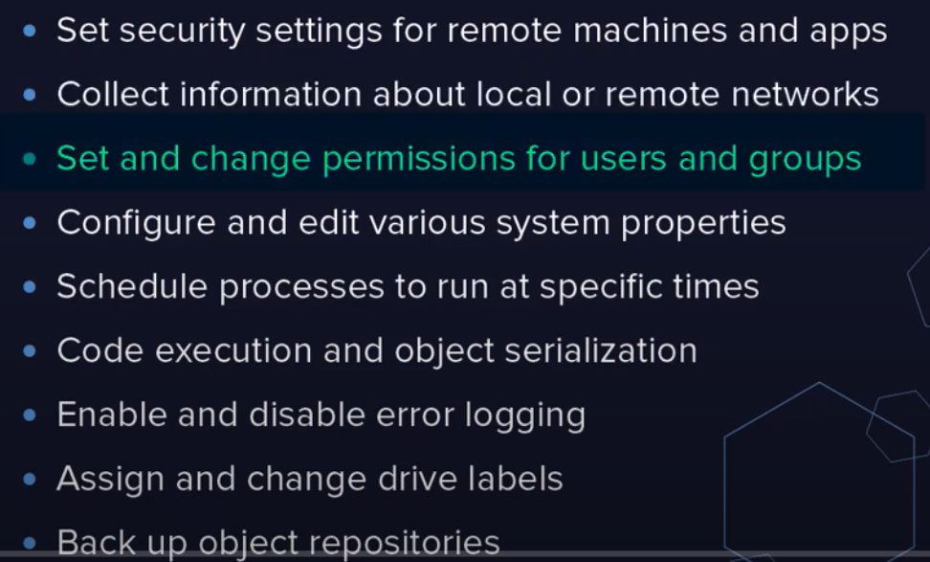

DMTF – distributed managed task force implements standards.

Standard:

CIM – Common Infromation Model (schema)

WBEM – Web-Based Enterprise management

WS MAN – Web Services Management

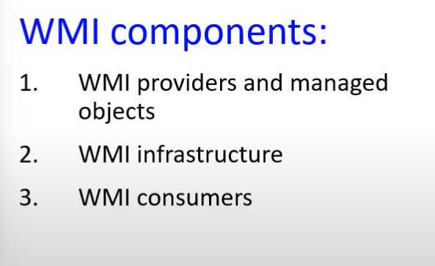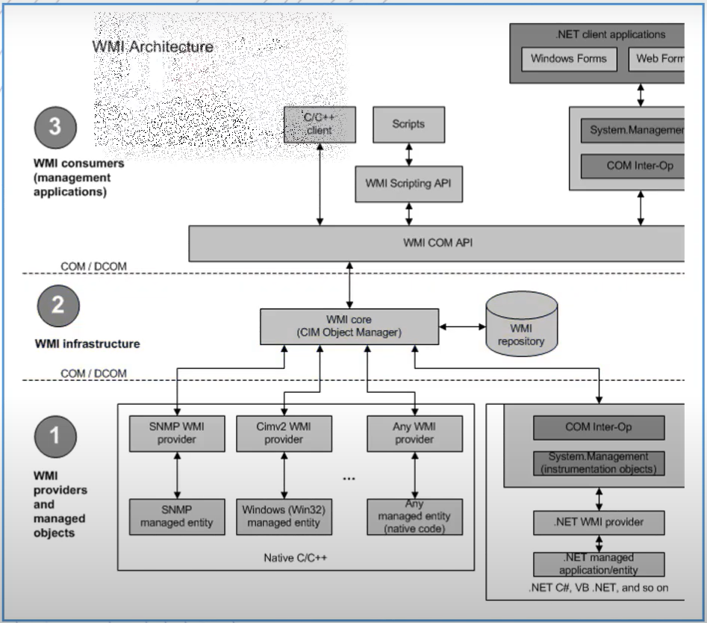

WMI provider consists of DLL and MOF (Managed Object Format),mof defines classes for which provider returns data and performs operations.

A provider monitors,read and collects data on a managed object(NIC,disk,application,services that can be managed via WMI).

**WMI infrastructure**

Components : WMI core,WMI repository

WMI service acts as an intermediary between providers, application and repository



Gets all namespaces

**Set-ExecutionPolicy -ExecutionPolicy Unrestricted**

